

|  |
| --- |
| MCTR903 |
| **The Pendubot** |
| Project Proposal |

|  |
| --- |
| Proposed by: 1. Mona Elboughdady ID: 43-16697  2. Ahmed Zaghloul ID: 43-1  3. Bishoy Atef ID: 43-  4. John Gameel ID: 43-  5. Abdo Saad ID: 43-  Proposed to: Prof. Ayman Elbadawy  10-19-2021 |

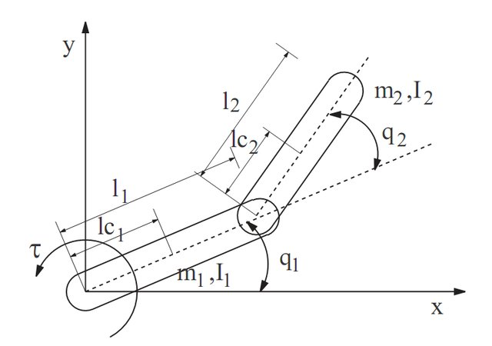

**The** **Pendubot**

The Pendubot system is a 2-link underactuated planar system (which has fewer number of actuators than the degrees of freedom). It has a single actuator at the base or first joint while the second joint, between the two links, is unactuated and can swing freely. This system is mainly used for research to study the underactuated robotic systems. The main goal is to swing up and balance the robot about the unstable upright position (where both links are in the vertically up configuration). The swing up and balancing techniques are done by either one controller or two controllers and switching is done between the two controllers.



**The system inputs**

The input to the system is the torque applied from the motor.

**The system outputs**

The system outputs are the angular positions and the angular velocities of the two links.

**The system states**

The system states are the angular positions and the angular velocities of the two links.